

**Who are we & when are the camps?** The Western Institute for Scholarly Education

(WISE) provides engaging and educational science and math summer camps for students entering grades 3-9 who are performing above grade level. WISE camps take place August 8-12 and August 15-19, 2016 and are located at **Newport High School in Bellevue**, WA. There are morning (8:30/9-12:00) and afternoon (1-4/4:30) camps available with the option to double up & eat a free lunch on campus while enjoying fun activities!

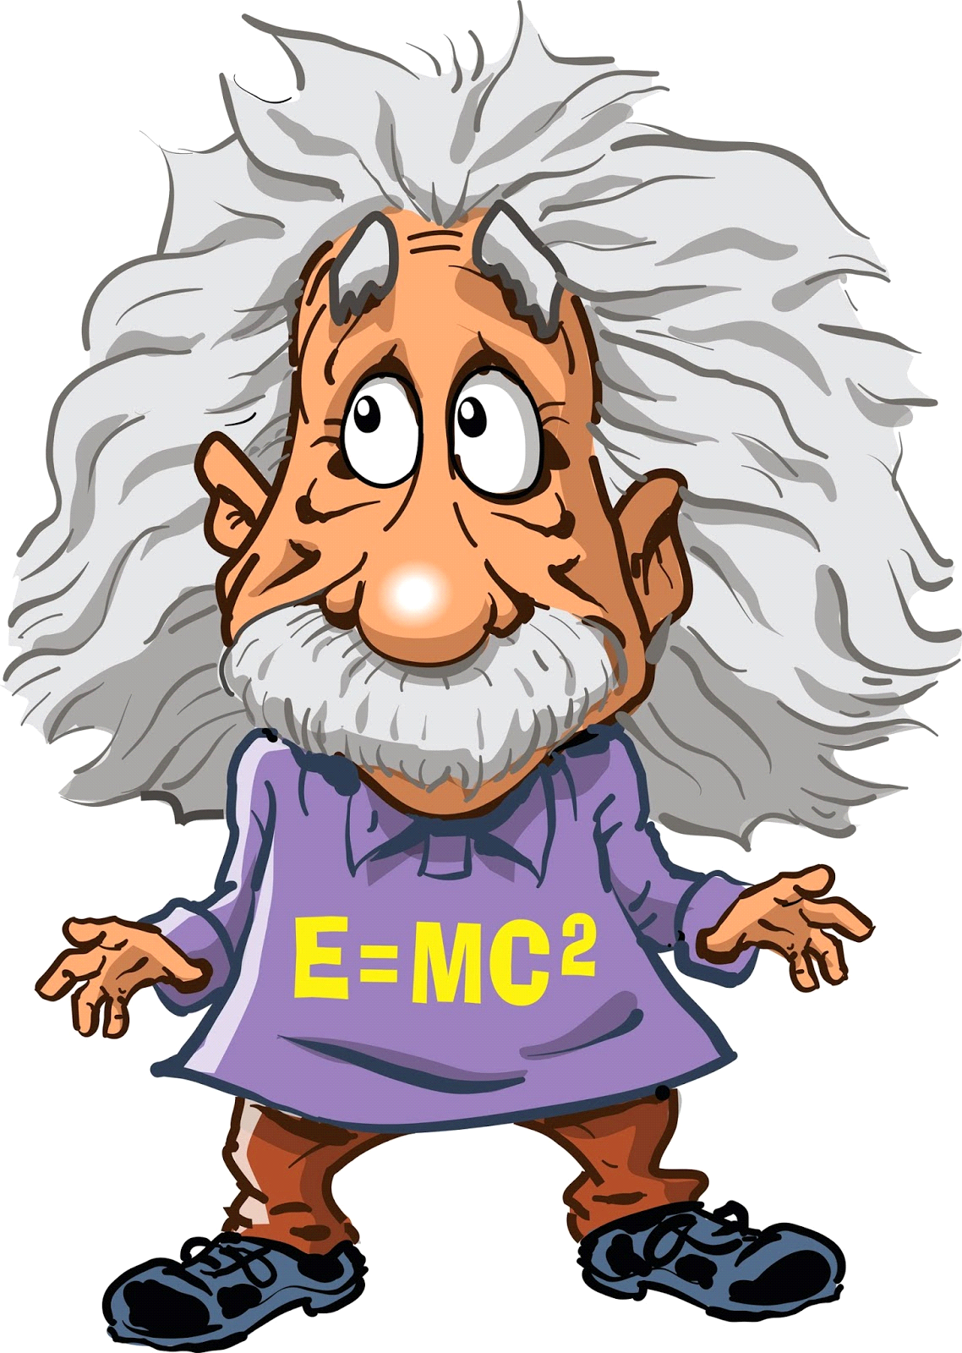 **Real Genius! (**Grades 3-5) 8/8-8/12 OR 8/15-8/19, 9:00-12:00 OR 1-4:00



Math will come alive for you in this camp as you get to solve exciting problems! We’ll use hands-on activities to allow you to go further faster in your mathematics knowledge! Strong math skills are not necessary.



**Chemistry Wizards! (**Grades 3-5) 8/8-8/12 OR 8/15-8/19, 9:00-12:00 OR 1-4:00



Would your child be interested in performing exciting experiments? The young scientists in this class will learn about the periodic table, density and do some actual chemistry!



 **Rapid Math! (**Grades 6-9) 8/8-8/12 OR 8/15-8/19, 8:30-12:00 OR 1-4:30

Are you a strong math student looking to gain an edge over your peers? You will preview *every* high school math class through basic calculus. We’ll explore geometry, trig, algebra 2, pre-calc, and AP stats!





Ever wondered how crime scene investigators use their science skills to solve mysteries?  This course introduces campers to a mix of the biology, physics, chemistry, and math used by real forensic scientists!



**Chemistry is a BLAST! (**Grades 6-8) 8/8-8/12 OR 8/15-8/19, 8:30-12:00 OR 1-4:30



Are you interested in being a mad scientist for a week?! Chemistry is a BLAST is designed to give students with an interest in science a chance to get hands-on experience with lab equipment and learn basic chemistry!



 **Chemistry is a BLAST Part 2! (**Grades 6-9) 8/15-8/19, 8:30-12:00 OR 1-4:30

Couldn’t get enough chemistry in the first camp? Welcome back you mad scientist you! Acids, bases, and titrations, oh my! We will explore topics like calorimetry, organic chemistry and nanotechnology!

**All camps offered last summer completely filled up! Register today at wisecamps.com**

Included in the cost ($225-249) is a camp t-shirt and lunch is provided for full day campers (2 sessions)!

Questions? Email or Call Camp Directors Melissa Baker (Chemistry) or Jake Nonis (Math): [wisecamps@gmail.com](mailto:wisecamps@gmail.com), 425-296-9767

The Bellevue School District does not sponsor nor endorse this event and/or information, nor does the district assume responsibility for it. In consideration of the privilege to distribute materials, the Bellevue School District will be held harmless from any cause of action filed in any court or administrative tribunal arising out of the distribution of these materials, including costs, attorney’s fees and judgments or awards.